Writing for Uganda at Bassaleg Comprehensive

Eco-Schools is the largest sustainable schools programme in the world and is operated by the Foundation for Environmental Education (FEE). It is funded in Wales by the Welsh Government and run by Keep Wales Tidy.

Project Officer | Bryony Bromley
Local Authority/area | Newport
Date /Period | July 2016
School name | Bassaleg Comprehensive
Event title | School linking in Uganda and literacy for all
Award level of school | Platinum

The Project
Main aim of the project |  | To create an effective link with a school in Uganda that benefits the pupils in both locations.
Which of Eco-Schools ‘7 steps’ are covered? |  | Action Plan, Informing and Involving, Monitoring, Linking to the Curriculum
How was the need for the project identified? |  | Through early ESDGC planning and reviews.
What did they do? |  | 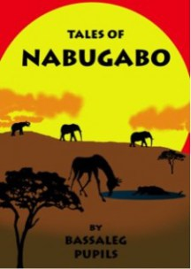  A link with a school in Uganda was established several years ago and has developed from strength to strength over the years. Fundraising activities are carried out regularly and used to support the pupils in the link school. As the pupils in Bassaleg are able to see the outcome of their fundraising, they are continually motivated to do more.  As well as some fantastic new infrastructure, the funds from Bassaleg have enabled every child in the link school to have a breakfast of porridge, helping with their health, nutrition and ability to learn.  After sending out some reading books, pupils in Bassaleg found that the children in Uganda struggled to use them as they didn’t identify with the stories. They therefore decided to research and write their own book of stories that were relevant to the pupils of Uganda  http://www.thehugepartnership.org/the-tales-of-nabugabo-bassaleg-school/  “‘Tales of Nabugabo’ focuses on the African ‘Tinga Tinga’ style animals painted on the walls of NCLC, who come alive when the children go home from school. Each story tells of an adventure the animals get up to in the school and the surrounding area of Balla village and Lake Nabugabo. Year 8 pupils took on this challenging literacy project and immersed themselves in a day of creative writing, illustration and drama workshops before writing their stories. A team of Year 11 & 12 pupils then worked tirelessly to turn the stories into a children’s story book. The end product was truly outstanding.”  Copies were sent out to the school in 2015 and the pupils and staff were overwhelmed to have had a set of stories written about their school and community.
Who was involved in the project? |  | Pupils and staff from across the school and pupils and staff from Nabugabo in Uganda.
How was the project shared with the whole school community? |  | Through the noticeboard and website.  http://www.thehugepartnership.org/the-tales-of-nabugabo-bassaleg-school/  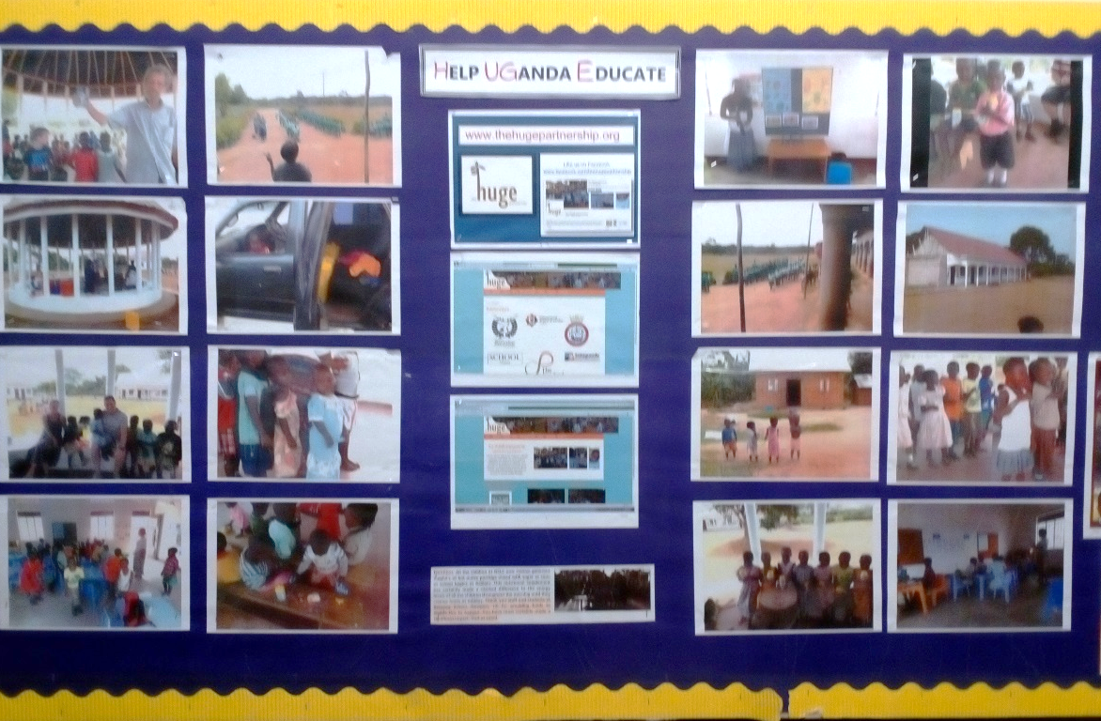

Curriculum Links
How did the school link this into the curriculum? |  | Pupils learn about their link school throughout the school.  Art department painted murals in school linked to Nabugabo  Literacy project to produce stories relevant to pupils in Uganda  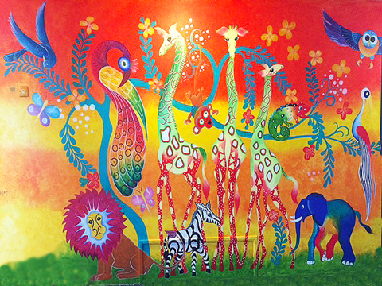  School has a dedicated ‘Global Learning’ lesson that can be utilised to look at the global impact of issues, including life in Uganda.
Please highlight how this links to the literacy and/or numeracy framework |  | Literacy: Please tick  Oracy – Developing and presenting information and ideas X  Reading – Locating, selecting and using information X  Reading – Responding to what has been read (comprehension, response and analysis) X  Writing – Organising ideas and information X  Writing – Writing accurately X  Numeracy:  Developing numerical reasoning – Identify processes and connections  Developing numerical reasoning – represent and communicate  Developing numerical reasoning – Review  Number skills – Use number facts and relationships  Number skills – Fractions, decimals, percentages and ratio  Number skills – Calculate using mental and written methods  Number skills – Estimate and check  Number skills – Manage money  Using measuring skills – Length, weight/mass, capacity  Using measuring skills – Time  Using measuring skills – Temperature  Using measuring skills – Area and volume, angle and position  Using data skills – Collect and record data, present and analyse data, interpret results. X
Please indicate which a) key skill and b) subject was utilised in this project and under which area of the curriculum (KS2, 3, 4). |  | More detailed info at http://wales.gov.uk/topics/educationandskills/schoolshome/curriculuminwales/arevisedcurriculumforwales/nationalcurriculum/?lang=en  Welsh  Music  English X  Mathematics  Modern Foreign Languages  Science  ICT  DT  History  Geography X  Art and Design X  PE  Welsh Baccalaureate  Developing thinking X  Developing Communication X  Developing ICT  Developing number  Curriculum Cymreig  PSE X  Careers and world of work
Measure of Success/monitoring |  | 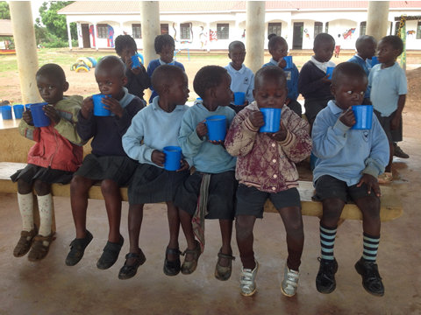  Global Citizenship  £9235 raised for the school so far which has resulted in:  - All pupils in the link school receiving porridge for breakfast every day.  - A new brick kitchen with a three pot stove  - A toilet block and a shower block  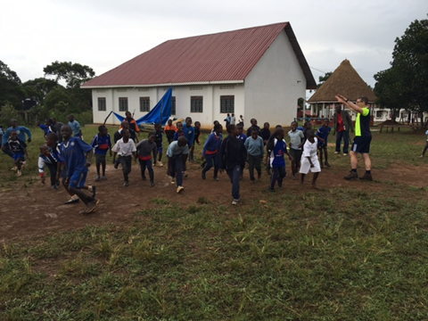  A book has been published for pupils in Uganda to use to practice reading and donations of clothes and toiletries have been sent out to the school.
In your personal opinion, why is this good project example?

This project goes so far beyond the average linking project as it had seen huge benefits to pupils in both schools. Being able to see the impact that is being made to others’ lives is so incredibly motivating and rewarding for the pupil of Bassaleg but they are also benefiting from learning about the culture and way of life for the pupils in the Ugandan school. Having to research local culture and folklore in order to write the stories was an incredibly rich learning experience for the pupils in Bassaleg.

Fair Trade In Football Campaign Tournaments,
Pembrokeshire Schools.

Eco-Schools is the largest sustainable schools programme in the world and is operated by the Foundation for Environmental Education (FEE). It is funded in Wales by the Welsh Government and run by Keep Wales Tidy.

Project Officer | Kiri Howell.
Local Authority/area | Pembrokeshire/Carmarthenshire.
Date/Period | Summer terms 2014-2016.
School name | Tavernspite CP School (host school for Pembs./Carms. school tournaments)
Event title | Fair Trade In Football Campaign.
Award level of school | Platinum (all other schools involved are now Silver, Green Flag Level 1 and Platinum awarded schools).

The Project
Main aim of the project |  | To raise people’s awareness of the fairtrade and Fairtrade™ concepts and encourage the purchasing of fairtrade footballs for schools and sports clubs.
Which of Eco-Schools ‘7 steps’ are covered? |  | All, especially Informing and Involving.
How was the need for the project identified? |  | Children and the Eco-Coordinator at Tavernspite School were aware that they had to cover ESDGC and Healthy Living as part of their Eco-Schools work and identified this campaign as a fun way to meet both these topic requirements.
What did they do? |  | Tavernspite CP School contacted Fair Trade Wales/Fair Trade Schools in 2014 when they were looking for a community project to meet the Eco-Schools’ Platinum renewal criteria, since then they have hosted and organised Fair Trade football tournaments for schools across Pembrokeshire and Carmarthenshire.
Who was involved in the project? |  | 20 schools, hundreds of pupils, staff, parents and governors have all been involved in this campaign project. Local business Kilgetty Co-op who donated fair trade bananas for the players and Scottish business Bala Sports www.balasport.co.uk/fairtrade-balls/ who now design and sell fairtrade and other ethical footballs.
How was the project shared with the whole school community? |  | The campaign is widely promoted by Fair Trade Wales. Tavernspite and competing schools advertised the tournament at county level/local authority head teacher meetings. Pembrokeshire Schools led a fair trade football selfie social media campaign. Local press coverage. School pupils were involved as supporters and spectators on the day and follow up assemblies on the fair trade theme were held in all the competing schools.
What external resources did the school use on this activity?  Where do they generally get their resources from? |  | The following links have resources, help and information relating to fair trade schools, campaign, products etc that will assist teachers and coordinators in tackling the ESDGC/Healthy Living Eco-School topics:  http://www.fairtradeinfootball.com/  http://fairtradewales.com/fair-trade-nation/schools/become-a-fairtrade-school  http://fairtradewales.com/resources  http://fairtradewales.com/resources/teaching-learning

 | Curriculum Links
 | How did the school link this into the curriculum? |  |  |  | 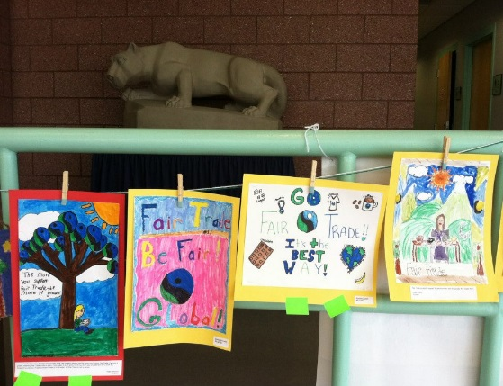  English, Welsh and Art were covered in creating fair trade posters to display at the tournament days:  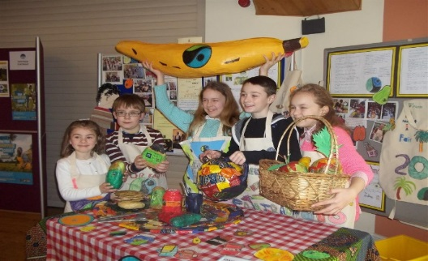  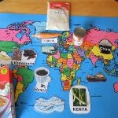  Fair trade items were replicated in DT and Art to sell at Pembrokeshire enterprise fair (along with fairtrade fruit and reusable bags) while Numeracy was covered when investigating percentages of sales relating to the fairtrade premium raised via the sale of Fairtrade footballs in Pembrokeshire.  Pupils covered Geography topics too by creating fair trade food mile maps.
 | How else could the school link this project into their curriculum? |  |  |  | The schools used the campaign as a vehicle for delivering ESDGC and PE in the main, but also looked at a variety of topics including English, Welsh, Maths, Geography, Art and PSE. More use could have been made of the campaign by looking at the links to fair trade via History and Science by comparing and contrasting lives in developing and developed countries and the effects that developed and developing countries have on the contemporary global environment. Much further work could be done on this theme in the topics of Music and Modern Foreign Languages also, in relation to the countries of production. More schools could twin with schools too.
 | Please highlight how this links to the literacy and/or numeracy framework |  |  |  | Literacy: Please tick  Oracy – Developing and presenting information and ideas Y  Reading – Locating, selecting and using information Y  Reading – Responding to what has been read (comprehension, response and analysis) Y  Writing – Organising ideas and information Y  Writing – Writing accurately Y  Numeracy:  Developing numerical reasoning – Identify processes and connections Y  Developing numerical reasoning – represent and communicate Y  Developing numerical reasoning – Review Y  Number skills – Use number facts and relationships Y  Number skills – Fractions, decimals, percentages and ratio Y  Number skills – Calculate using mental and written methods Y  Number skills – Estimate and check  Number skills – Manage money Y  Using measuring skills – Length, weight/mass, capacity  Using measuring skills – Time  Using measuring skills – Temperature  Using measuring skills – Area and volume, angle and position  Using data skills – Collect and record data, present and analyse data, interpret results. Y
 | Please indicate which a) key skill and b) subject was utilised in this project and under which area of the curriculum (KS2, 3, 4). |  |  |  | More detailed info at http://wales.gov.uk/topics/educationandskills/schoolshome/curriculuminwales/arevisedcurriculumforwales/nationalcurriculum/?lang=en  Welsh Y  Music Y  English Y  Mathematics Y  Modern Foreign Languages Y  Science y  ICT Y  DT Y  History Y  Geography Y  Art and Design Y  PE Y  Welsh Baccalaureate NA  Developing thinking Y  Developing Communication Y  Developing ICT Y  Developing number Y  Curriculum Cymreig Y  PSE Y  Careers and world of work Y
 | Measure of Success/monitoring |  |  |  | 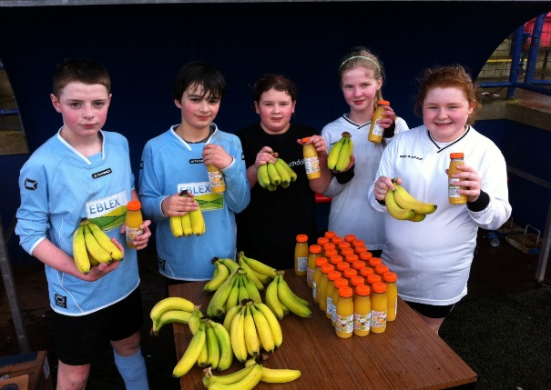  Healthy Living  Over 200 Fairtrade bananas were donated by co-op on the tournament days.  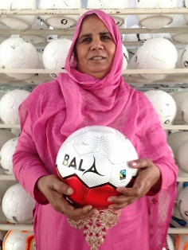  Global Citizenship  20 Fairtrade footballs have been purchased in Pembrokeshire due to this project.
In your opinion, why is this good project example?

This is an excellent and fun way of involving schools and communities in understanding ESDGC and fair trade themes. The projects worked well as it is a fun, sporty and competitive activity that many pupils can engage and learn from. The benefits of such a tournament is that is raises the profile of the fair trade in football campaign at a high, multi school level. The pupils benefit from it via a healthy experience, but also learn about the direct effect their purchasing can have on people’s working and living conditions. Other benefits have been highlighting the clear links between fair trade and the ESDGC topic criteria of the Eco-Schools process and how UK businesses have been involved and have benefited from the campaign i.e. in the UK with Bala Sports and in other countries; Sialkot in Pakistan.

Did this activity lead to any behaviour change OUTSIDE of the classroom i.e. at home?
Mrs Sophie James, mother of Tavernspite pupil Katie James aged 8, says:

“Katie played in the fair trade tournament at school which I went to watch, I was amazed at the conditions that people work in to make standard footballs. I was happy to buy Katie a new fair trade ball at the event. It really made me think about how we take things for granted here in Wales”.

A Healthier Wales – a society in which people’s physical and mental wellbeing is maximized and in which choices and behaviors that benefit future health are understood. |  | This campaign has supported schools to undertake a novel sporting activity that physically benefits pupils in Wales as well as helping communities further afield. Pupils and parents have been informed of the choices available to them when buying footballs. 20 fairtrade footballs have been sold in Pembrokeshire since the first tournament in 2014 and the benefits of this are far reaching. Katie James, aged 8 states how:  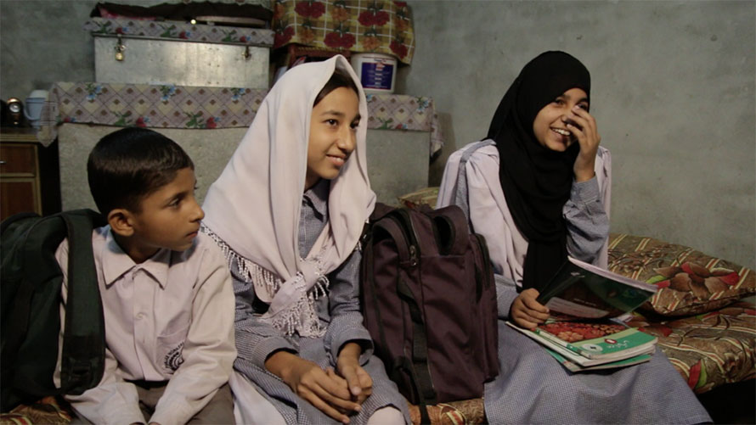  “I was really pleased that my mum bought me a special fairtrade ball. I play a lot of football and am glad that my new ball has meant that someone’s family life in Pakistan is made easier because of me buying it”.  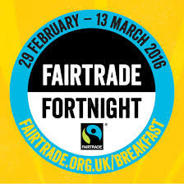  Picture showing school children in Sialkot who could purchase school books with their fairtrade premiums direct from the fairtrade sales in Pembrokeshire schools.  The campaign has also encouraged schools to choose healthy and fairtrade fruit for break and half time. Over 200 hundred fairtrade bananas were eaten over the tournament days.  Taverspite Head Teacher Mr Kevin Phelps states:  “This tournament has showed the value that sport can play in helping others, it has definitely enhanced the health and wellbeing of the school community by providing a novel physical activity. It has also shown that there are many connections to fairtrade that schools can make use of including fairtrade fortnight and becoming a fairtrade school. I am very proud that my school has led the way for future tournaments for such a great cause”.
A more equal Wales  – a society that enables people to fulfil their potential no matter what their background or circumstances. |  | This campaign has encouraged schools to undertake projects to understand how inequality affects lives (e.g. what are fair and unfair situations) and to get involved in fair trade activities to better understand its principles.  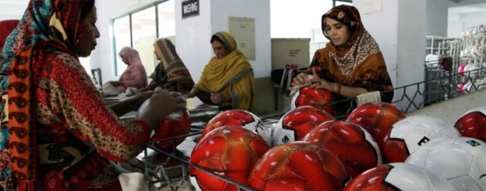  Campaign founder Sharon Hardwick states: ““Supporting local and Sialkot stitching communities is what the campaign is all about. We want to offer fun Fairtrade activities for local schools and clubs so they can connect with each other and with the football workers who make the Fairtrade balls, ensuring them: a fairer deal, safe working conditions, with rights and the extras that the Fairtrade premium bring; like free eye care, school equipment, a water filtration system, a fair shop, safe and free transport to work and more. Campaigns like this really enthuse the pupils and their families in this support work”  Picture showing a fair trade football cooperative in Sialkot, Pakistan which supply footballs to Bala Sports, Scotland.
A prosperous Wales – an innovative and productive, low carbon emission economy that makes more efficient and proportionate use of resources; and which generates wealth and provides employment opportunities for a skilled and well-educated population. |  | This campaign provides a wealth of resources for teachers and Eco-School coordinators to innovative curriculum links (with focus on the Numeracy and ESDGC Common Understanding Framework). The details and resources listed in this case study will highlight the many links to be found within Numeracy, ESDGC, PSE and the Eco-Schools programme itself, which will all assist in the development of a more prosperous, fairer and future proof Wales.  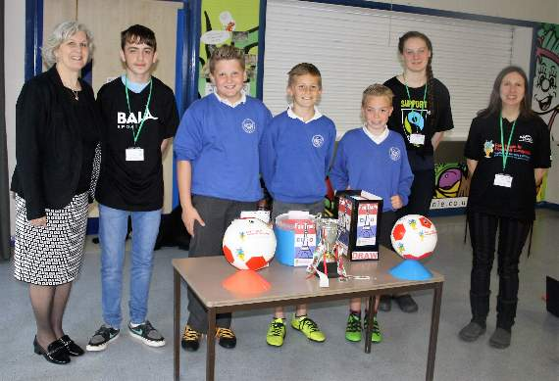  Picture showing Sharon Hardwick and pupils from Tenby Junior School:
A globally responsible Wales – a nation which when doing anything to improve the economic, social, environmental and cultural well-being of Wales takes into account its contribution to global well being |  | 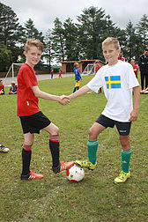  This campaign encourages schools to link with schools in other countries. It has also encouraged linking between partners and other local/global organisations and helped to raise awareness around issues of being an ethical/sustainable consumer. Pupils and parents have been educated on how they can make responsible changes in their homes and schools as Sharon Hardwick explains how:  “Bala Fairtrade balls are made to the same standards that FIFA use. The really good thing is that when workers are paid to make a Fairtrade Bala ball they benefit from the extra 10% Fairtrade Premium, and they decide democratically on what social development schemes to spend it on – so it’s a win-win for all”.  Pembrokeshire and Carmarthenshire football players:
 | Project Publicity |  | http://www.tenby-today.co.uk/article.cfm?id=105000&headline=Fair Trade Euro 2016 draw&sectionIs=news&searchyear=2016  @EcoPembs
 | Twitter # |  | #fairtradeinfootball
 | Plans for the future |  | The schools involved intend to promote the fair trade football tournaments to encourage more schools to partake in the future. By learning more about fair trade, it is hoped that schools will become fair trade schools (which strengthens the Eco-School criteria and process too).
 | Project Summary |  | The Fair Trade In Football Campaign tournament, Pembrokeshire, initially took place due to Tavernspite CP School needing to meet the Platinum Eco-School renewal criteria which requires a community based project (other involved schools required evidence to meet the whole school ESDGC Eco-School topic). Sharon Hardwick, Fair Trade Football campaign founder was contacted to assist the schools in the process of setting up a Pembrokeshire Fair Trade Tournament. Since this, over 200 school pupils in Pembrokeshire and Carmarthenshire have been involved in the tournaments. Schools and wider communities have all been involved in delivering the tournament days which have raised direct revenue for Fairtrade cooperatives in Sialkot, Pakistan. Schools have made good use of a wealth of resources available to them on the ESDGC, fair trade and Fairtrade™ themes. The main outcome of this project has been the awareness raising of the fair trade scheme and its links to Eco-Schools work. Many schools who have taken part in the tournament have used it as evidence for progressing with their Eco-Schools awards, while 20 Fairtrade footballs have been sold in Pembrokeshire, with 10% of this revenue going back into supporting community cooperatives in Pakistan.

